



To create a simple transaction system using classes and objects in Python
LAB MANUAL

Disclaimer: The content is curated from online/offline resources and used for educational purpose only
To create a simple transaction system using classes and objects in Python

Objectives:
- To understand the creation and management of a bank account system using Object-Oriented Programming (OOP) in Python.
- To define and use a BankAccount class with attributes such as account number, holder's name, and balance.
- To implement methods within the class that allow deposits, withdrawals, and balance inquiries.
- To handle valid and invalid transactions (e.g., insufficient funds or negative deposits) appropriately.
- To demonstrate how Python classes can be used to simulate real-world systems like a banking transaction system.
Problem Statement:
The task is to design a simple bank account management system using Python’s OOP features. Users will be able to create a new bank account, make deposits, withdraw money (as long as the withdrawal does not exceed the balance), and check their balance. This system will make use of basic OOP concepts such as classes, objects, constructors, and methods.
Procedure:
Task 1: Define the BankAccount class
Task 2: Implement the BankAccount Class
Task 3: Implement Deposit and Withdraw Methods
Task 4: Check the Account Balance
Task 5: String Representation of the Account

Code:
Task1: Define the BankAccount class
The BankAccount class will represent a bank account with various attributes and methods.

Task 2: Implement the BankAccount Class ()
The __init__ constructor initializes the account number, holder's name, and balance (defaulting to 0). Attributes self.account_number, self.holder_name, and self.balance store the account details.
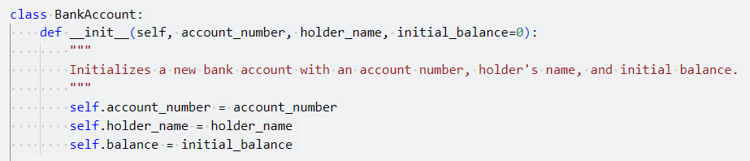

Task 3: Implement Deposit and Withdraw Methods
The deposit() method adds the specified amount to the balance.
It ensures that only positive amounts can be deposited.
The withdraw() method subtracts the requested amount from the balance, but only if the withdrawal amount is positive and does not exceed the available balance.
If the balance is insufficient, an error message is displayed.

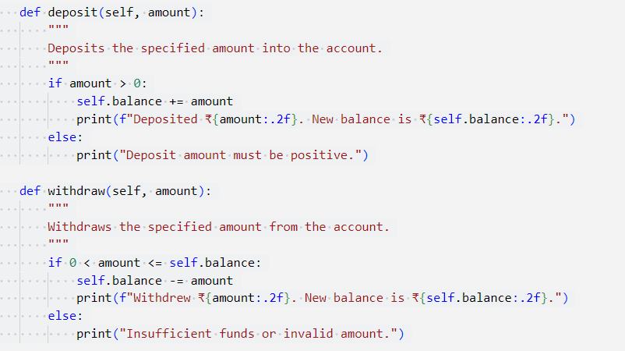

Task 4: Check the Account Balance
The get_balance() method allows the user to check their current balance.
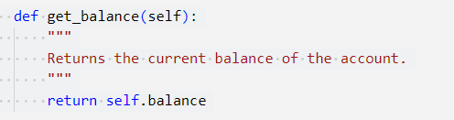

Task 5: String Representation of the Account
The __str__() method provides a formatted string representation of the bank account, including the account number, holder's name, and balance. This helps in displaying account details in a readable format.
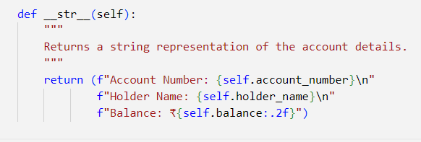
Example used:
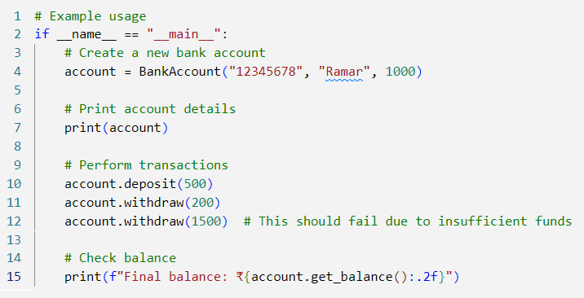
- Create a New Account: The program creates an account for "Ramar" with an initial balance of ₹1000.
- Deposit ₹500: The user deposits ₹500, and the balance increases to ₹1500.
- Withdraw ₹200: The user withdraws ₹200, and the balance decreases to ₹1300.
- Attempt to Withdraw ₹1500: This withdrawal fails because the balance is insufficient, and the user is notified with an error message.
- Check Final Balance: The final balance of ₹1300 is displayed.

Output:
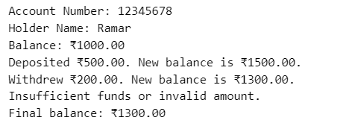

The BankAccount class, users can create accounts, make deposits, withdraw funds, and check their balance, with proper validation to ensure a smooth transaction process.

Disclaimer: The content is curated from online/offline resources and used for educational purpose only

